LAB EXPERIMENT NO # 09
Name: __________________________________ Date: ________________________
Score: __________________________________Signature of Instructor___________
Voltage Divider and Current Divider Rules
PERFORMANCE OBJECTIVE:
- To verify the current divider and voltage divider rules.
- Verify measurements with calculated values.
EQUIPMENT AND COMPONENTS:
- Multimeter
- Power supply
- Connecting Leads
- Breadboard
- Few Resistors
- Ohmmeter
- Voltmeter
- Ammeter
Introduction:
Voltage Division:

Voltage Division is used to express the voltage across one of the several series resistors in terms of the voltage across the combination.

In the Circuit shown below, Voltage V is divided across the resistors R1 and R2. The Voltages across each resistor which are V1 and V2 can be determined by the Voltage division rule.

FIGURE 1
For a series combination of N series resistors,

V_{k} = (R_{k} / R₁ + R₂ + R₃ +………..+ R_{n}) V

Current Division:

Current Division is used to express the current through one of the several parallel resistors in terms of the current through the combination.

In the Circuit shown, current I is divided between the resistors R1 and R2. The currents through each resistor which are I 1 and I 2 can be determined by the current division rule.

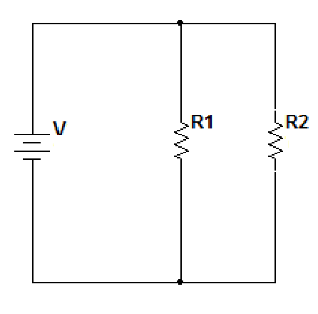
FIGURE 2
For a parallel combination of N series resistors,
I_{k}= (1/R_{k} / (1/R₁ + 1/R₂ +…….. + 1/R_{n})) I
PROCEDURE:

V = ________ R1 = ________ R2 = ________ R3 = ________ R4 = ________

For the given circuit in figure 3 verify VDR. First calculate the voltage using the formula and write them in Table 1.
Secondly measure the voltage by multimeter through R1, R2, R3, and R4. Then compare the voltages obtained by calculation to the voltages obtained by multimeter. Write them in Table 1.

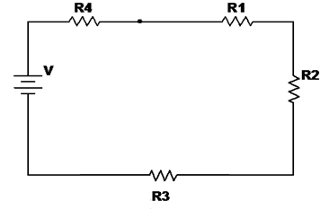

FIGURE 3
Table 1

For the given circuit in figure 4 verify CDR. Pick the resistors from resistor tray, write their values below and measure current I for R1, R2, R3 and R4 using ammeter. Fill the Table 2 by calculating current first by CDR and then write the measured values through ammeter.

I = ________ R1 = ________ R2 = ________ R3 = ________ R4 = ________
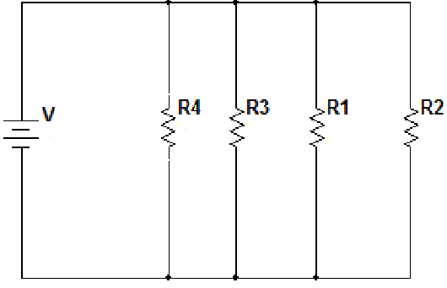

FIGURE 4
TABLE 2

CONCLUSION

